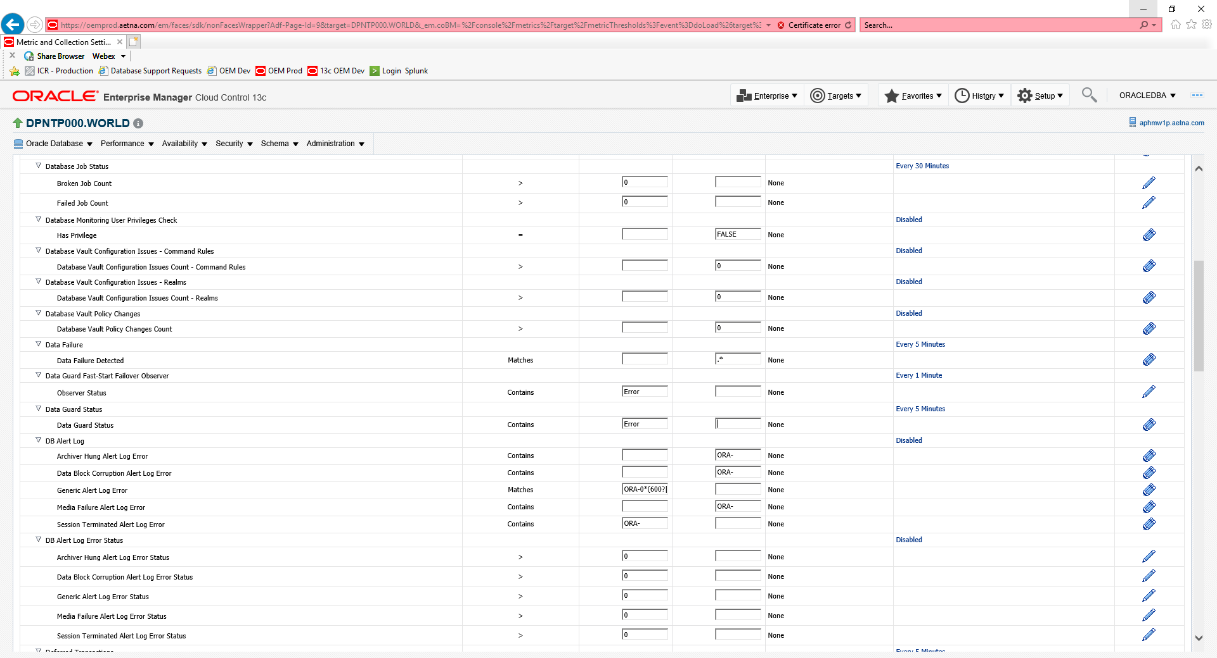

Change Data Guard Status in first column from Warn to Error and whipped out Error from other column and leave blank. Hit ok.

Reverse after Stanby is up.

